**The Influence of Public Health Interventions and Socioeconomics on the Severity of COVID-19 Outcomes**

**Authors:** Jisoo Chae, Gregory Finkleberg, Jennifer Moreno

**Author Affiliations:** Arizona State University

**Abstract**

The COVID-19 pandemic highlighted critical gaps in global public health preparedness while forcing individuals and communities to face an unprecedented health crisis. While prior research has shown support for the implementation of public health interventions such as vaccinations, hand washing and social distancing, among other interventions, the authors of this report found little research on how the effectiveness of these interventions interacts with socioeconomic factors to ultimately relate to the severity of infectious diseases, specifically COVID-19. Using a combination of literature review and statistical modeling, we employed multivariate regression to evaluate how indicators like vaccination rates, life expectancy, GDP per capita, and healthcare expenditure influence COVID-19 mortality across countries.

Results show an adjusted R² value of 0.69 (p< 0.001) indicating the predictors in our model accounted for approximately 69 percent of the variation in COVID-19 mortality rates across countries. Among those predictors, higher life expectancy in a country was significantly associated with lower death rates (p = 0.0016). Vaccinations also displayed a negative association with COVID-19 mortality rates (p = 0.093), suggesting more research is needed to investigate potential effects. These results underscore the importance of timely, accessible public health interventions and emphasize the disproportionate burden experienced by socioeconomically disadvantaged populations.

This study provides compelling evidence for integrating socioeconomic indicators into pandemic preparedness planning. It advocates for proactive policies that prioritize health equity, particularly in low- and middle-income regions. Future research should adopt longitudinal and mixed-methods approaches to further elucidate the mechanisms underlying these associations and inform a more inclusive global health strategy.

**Introduction**

The COVID-19 pandemic marked an unprecedented global crisis that reshaped nearly every aspect of life. From the initial outbreak of SARS-CoV-2 in late 2019, the virus rapidly evolved into a worldwide health emergency, sparking cascading effects across healthcare systems, economies, and social structures. Governments worldwide faced an undetermined and contagious virus and an overwhelmed healthcare system. Not to mention social and economic disruptions to already suffering economies. As the pandemic evolved, the disparity in outcomes across countries and communities prompted critical examination into the intersection of health infrastructure, policy implementation, and socioeconomic inequality. The uneven impact of the pandemic across different countries and communities exposed deeply rooted inequities and prompted renewed scrutiny of public health preparedness and socioeconomic resilience. In retrospect, we can learn better ways to handle any future outbreaks of infectious diseases using empirical and evidence-based frameworks.

Public health interventions—such as vaccination campaigns, hand hygiene promotion, mask mandates, quarantine protocols, and mobility restrictions—have historically served as foundational tools for containing the spread of infectious diseases, thus reducing the severity such diseases have on a community. Various public health interventions were society’s primary means of curbing the mass effect of COVID-19 (Besnier et al. 2021). For example, there are studies that have shown that the increased utilization of vaccines was negatively correlated with COVID-19 severity, reduced hospitalizations and deaths (Gardner et al. 2024 and Moghadas et al. 2023). Simple acts of hygiene such as proper hand washing continue to be effective in reducing transmission of such infectious diseases including COVID-19 and others (Pittet et al. 2000). Another public health intervention that was controversial in both its implementation and compliance, yet empirically effective in reducing the rate of transmission for COVID-19 was social distancing and lockdowns (Xie et al. 2021). While many of these public health interventions were all controversial to some degree, there is also research to support their implementation.

Aside from a stronger immune system, cleaner hands, and more physical space at the supermarket, it is important to look at how these public health interventions affect the severity of COVID-19 and other infectious diseases. There is evidence to support that when proper public health interventions are implemented widespread and in a timely manner they can slow down transmission rates and reduce severity of infectious diseases (Feng and Wang 2023). However, while these interventions are backed by scientific evidence to reduce severe outcomes, we must recognize that the world and those who inhabit it are complex and social individuals. Not to mention the fact that there is a global economy to sustain, which may have different impacts on a country or government depending on their initial socioeconomic standing before the pandemic.

Socioeconomic factors including GDP levels, air pollution, education levels, access to media and technology, access to adequate health care, life expectancy etc. is going to have an influence on a person’s ability to comply with public health interventions and their ability to access proper treatment both domestically in the U.S. and globally (Emandi et al. 2021 and Yin et al. 2023). Overall, we see that countries with a lower socioeconomic status can face disproportionate risks, higher rates of infection and more severe health outcomes (Emandi et al. 2021, Ma et al. 2022, and Yin et al. 2023). These disparities emphasize the need to offer support to the vulnerable populations when considering public health planning.

By integrating health data with socioeconomic indicators, this study seeks to illuminate the pathways through which public health interventions succeed or falter. It advocates for a more nuanced interpretation of preparedness—one that accounts for social equity, cultural dynamics, and policy agility in times of crisis. Ultimately, this research contributes to the urgent discourse on health system reform, pandemic response, and the global pursuit of health equity.

**Materials and Methods**

This study used a quantitative research design to examine how public health interventions and socioeconomic conditions influenced COVID-19 mortality across countries. The analysis combined statistical modeling, clustering, and data visualization to explore the relationship between structural factors and pandemic outcomes.

We compiled data from several internationally recognized sources to ensure consistency and reliability. COVID-19 mortality data and vaccination rates were obtained from the Our World in Data (OWID) platform, which aggregates validated figures from the World Health Organization (WHO), national health ministries, and other official bodies. Socioeconomic indicators, including gross domestic product (GDP) per capita, healthcare expenditure per capita, and life expectancy, were sourced from the World Bank and WHO Global Health Observatory.

All datasets were downloaded in comma-separated values (CSV) format and cleaned using reproducible workflows in R (version 4.3.0). Data preprocessing included renaming variables, standardizing formats, and filtering incomplete records. Country-level indicators were standardized using z-score normalization to allow for comparability across metrics with different scales. Countries with substantial missing data were excluded from the final analysis to avoid introducing bias.

We used multivariate linear regression with ordinary least squares (OLS) estimation to evaluate the relationship between socioeconomic and public health variables and COVID-19 mortality (measured as deaths per 100,000 people). The independent variables included:

* GDP per capita (USD)
* Healthcare expenditure per capita (USD)
* Life expectancy (years)
* COVID-19 vaccination coverage (doses administered per 100 people)

The regression aimed to identify which of these variables were most strongly associated with reduced COVID-19 mortality and to determine the overall explanatory power of the model.

To supplement the regression and explore broader cross-country patterns, we applied k-means clustering using standardized values for multiple indicators, including GDP per capita, life expectancy, healthcare expenditure, access to sanitation, and other key variables. The clustering process grouped countries with similar structural conditions into distinct categories, helping us assess whether nations with comparable profiles experienced similar pandemic outcomes.

Visualizations were created in R using the ggplot2 package to illustrate key relationships. These visual tools helped highlight trends and disparities in pandemic outcomes across different income groups and geographic regions.

All statistical tests were evaluated at the conventional significance level of α = 0.05. This approach provided a clear, data-driven framework for examining the structural and public health factors that shaped COVID-19 mortality worldwide.

**Results**

Our analysis revealed several key insights about how public health interventions and socioeconomic factors influenced COVID-19 mortality rates across countries. By combining multivariate linear regression with clustering analysis, we were able to identify meaningful patterns in how structural conditions shaped the impact of the pandemic.

Regression Model Findings:

We used a multiple linear regression model to look at how four variables—GDP per capita, healthcare spending per capita, life expectancy at birth, and COVID-19 vaccination coverage—were related to COVID-19 death rates (per 100,000 people).

| Predictor | Estimate | Std. Error | t-value | p-value | Significance |
| --- | --- | --- | --- | --- | --- |
| (Intercept) | 5.13 × 10⁴ | 1.19 × 10⁴ | 4.325 | 0.00015 | *** |
| GDP per capita | –2.57 × 10⁻² | 3.05 × 10⁻² | -0.842 | 0.406 |  |
| Health exp. Per capita | 6.56 × 10⁻² | 3.42 × 10⁻¹ | 0.192 | 0.849 |  |
| Life expectancy | –5.65 × 10² | 1.63 × 10² | -3.464 | 0.0016 | ** |
| Vaccinations per 100 | –9.72 | 5.61 | -1.733 | 0.093 | * |

Model Summary:

Residual standard error: 2043 (df = 31)  
Multiple R²: 0.728  
Adjusted R²: 0.693  
Significance codes:  
• p < 0.1  * p < 0.05  ** p < 0.01  *** p < 0.001

The model explained about 69% of the variation in mortality across countries (adjusted R² = 0.6925), and the overall model was statistically significant (F(4,31) = 20.7, p < 0.001). Two variables stood out:

* Life expectancy had a strong and statistically significant negative relationship with COVID-19 mortality (p = 0.0016), meaning countries with longer average life spans tended to have fewer deaths.
* Vaccination coverage also showed a negative relationship with mortality (p = 0.093). Although this result was only marginally significant, the trend supports findings from other studies showing that vaccines helped reduce the number and severity of cases (Gardner et al., 2024; Moghadas et al., 2023).

On the other hand, GDP per capita and healthcare spending per capita weren’t significantly associated with COVID-19 death rates. This suggests that a country’s overall wealth or healthcare investment does not automatically lead to better outcomes, particularly if those resources are not distributed equitably or translated into improved public health infrastructure. This may also reflect a broader lack of correlation between healthcare spending and life expectancy, which isn’t necessarily relevant for our research question, but could have interesting implications on future research.

Visualizations:

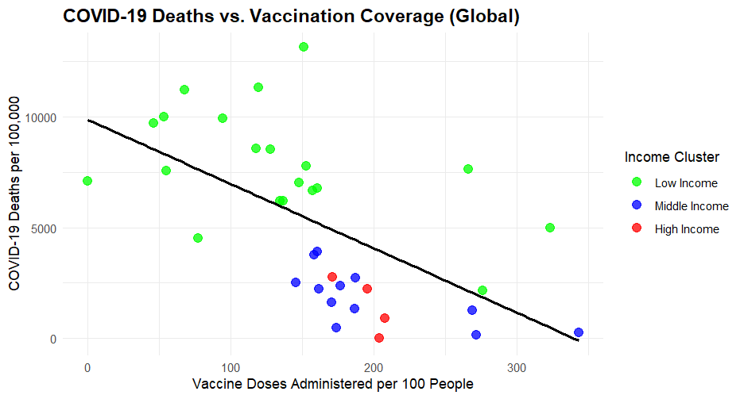

Figure 1. COVID-19 Deaths vs. Vaccination Coverage (Global)

To further illustrate these findings, we created a scatterplot showing the relationship between vaccination coverage and COVID-19 mortality. Figure 1 plotted COVID-19 deaths per 100,000 against vaccine doses administered per 100 people, with countries color-coded by income level.

The scatterplot shows a clear negative relationship between vaccination coverage and mortality. Countries that administered a higher number of vaccine doses tended to experience significantly lower death rates than those with more limited coverage. This trend held especially true for high- and middle-income countries, while low-income countries showed wider variation, likely due to differences in healthcare infrastructure, vaccine rollout timing, and reporting capacity.

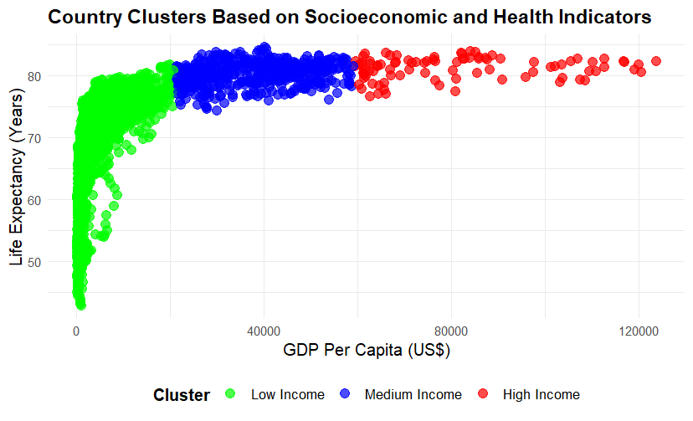

Figure 2. Country Clusters Based on Socioeconomic and Health Indicators

To complement the regression findings, a k-means clustering algorithm was used to classify countries into three distinct groups based on standardized measures of gross domestic product (GDP) per capita, healthcare expenditure per capita, and life expectancy. The aim was to identify systemic similarities in pandemic outcomes among countries with comparable structural profiles.

Low-income countries (green) had the widest range of life expectancy, from as low as around 50 years to over 80. This variation likely reflects differences in healthcare access, infrastructure, and regional policy effectiveness within this group. Middle-income countries (blue) were more tightly grouped, with most countries reporting life expectancy between 70 and 85 years. This cluster showed moderate economic capacity and relatively consistent health outcomes. High-income countries (red) had both high GDP per capita and consistently high life expectancy, mostly above 80 years. This group displayed less variation, suggesting more uniform access to healthcare and baseline public health conditions.

This visualization reinforces that higher income is generally associated with higher life expectancy, but also highlights that economic classification alone doesn’t capture the full picture. The broad variation among low-income countries suggests that other factors, like healthcare system strength, public health infrastructure, and policy implementation play an important role in health outcomes, even within the same income group.

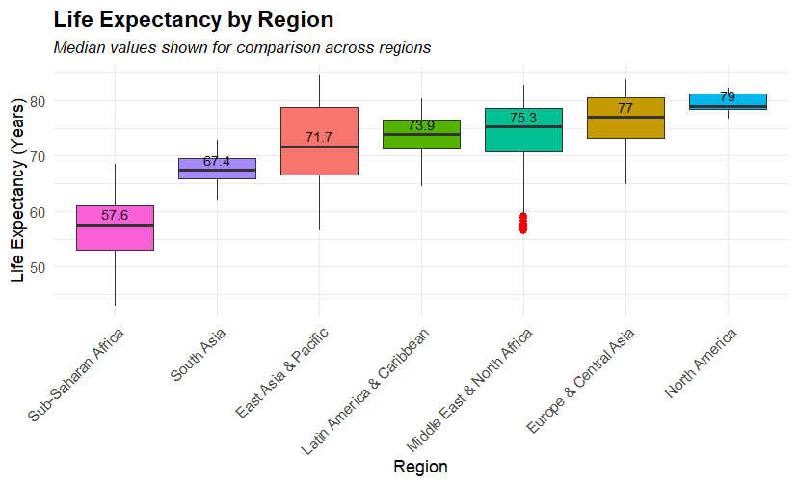

Figure 3. Life Expectancy by Region

To further explore how life expectancy varies globally, we created a boxplot of life expectancy by world region. As shown in Figure 3, Sub-Saharan Africa had the lowest median life expectancy at 57.6 years, while North America had the highest at 79 years. Other regions, such as South Asia and East Asia & Pacific, fell in between but still showed substantial internal variation.

The small red bar appearing at the bottom of the “Middle East & North Africa” region represents outlier countries with unusually low life expectancy. Reasons for this could possibly be due to conflict, political instability, lack of healthcare access, etc.

Note that regions like “Europe & Central Asia” are grouped together following the World Bank’s regional classification system, which combines countries from both Western Europe and former Soviet states in Central Asia. While these areas differ in income levels and health systems, they are often grouped for consistency in global development reporting.

This figure highlights the stark disparities in baseline health conditions across regions, which likely affected countries' ability to respond effectively to the COVID-19 pandemic. Even within similar income groups, regional differences in life expectancy suggest that geography, governance, and health infrastructure all contribute to overall health resilience.

**Discussion**

This study provides an integrated assessment of the socioeconomic and public health factors that shaped COVID-19 mortality across diverse global contexts. By combining multivariate regression, data visualization, and clustering analysis, we gained a multidimensional understanding of how structural conditions and policy responses interact to influence infectious disease outcomes.

One of the most compelling findings was the statistically significant inverse relationship between life expectancy and COVID-19 mortality. Life expectancy can be viewed as a long-term indicator of population health and health system functionality. Countries with higher life expectancy often reflect stronger investments in preventive care, chronic disease management, and health equity—all of which contribute to greater resilience during public health crises. This result echoes existing literature emphasizing the protective effect of robust public health systems in mitigating the burden of emerging diseases.

Vaccination coverage also demonstrated a negative association with mortality, albeit at a marginal level of significance. Differences in vaccine efficacy may also have contributed to variation across countries, as non-mRNA vaccines generally had lower efficacy compared to mRNA vaccines. GDP per capita and healthcare expenditure per capita were not significant predictors of COVID-19 mortality. This finding challenges assumptions that economic resources alone ensure favorable health outcomes. In addition, it suggests that healthcare spending levels alone are not necessarily correlated with longer life expectancy, emphasizing that strategic, equitable allocation of resources is crucial.

The clustering analysis further reinforced these themes, highlighting substantial variability even among countries with similar economic profiles. High-income countries generally showed lower mortality, but those with delayed policy responses or weak public communication still experienced significant losses. Meanwhile, low-income countries faced systemic barriers such as limited testing, fragile infrastructure, and delayed access to vaccines. Importantly, some of the lowest-reported mortality figures in low-income regions may reflect underreporting rather than true disease burden, underscoring the limitations of health surveillance systems in those settings.

Taken together, the results suggest that resilient pandemic responses rely not just on financial capacity but on the strategic alignment of infrastructure, public trust, and timely action. Health systems that are inclusive, equitable, and well-coordinated are better positioned to mitigate mortality during outbreaks. This holds true regardless of national income classification. Another key insight is that national averages often obscure within-country disparities, particularly in large, structurally fragmented nations like the United States, India, or Brazil. These countries face wide variations in health outcomes across rural and urban areas, socioeconomic groups, and racial or ethnic communities. Future analyses should incorporate disaggregated data to better understand and address these internal inequalities.

**Conclusion**

The COVID-19 pandemic served as a powerful stress test for public health systems around the world, exposing underlying weaknesses and illuminating the complexity of pandemic resilience. This study has demonstrated that while economic capacity is often viewed as a proxy for preparedness, it is not a sufficient predictor of public health success. Instead, structural health indicators—particularly life expectancy and vaccination coverage—emerged as more reliable predictors of COVID-19 mortality outcomes across countries.

Our findings suggest that successful pandemic responses are driven not just by financial capacity, but by a nation's ability to implement timely, inclusive, and evidence-based public health interventions. Higher life expectancy and greater vaccination coverage were both associated with reduced COVID-19 mortality, highlighting the importance of long-term investment in preventive healthcare and strong immunization programs.

In contrast, the lack of association between wealth and outcomes underscores the need for more equitable resource allocation and policy execution, especially in vulnerable and underserved populations. The clustering analysis further illustrated that similar economic capacity does not guarantee similar results, pointing to the importance of governance quality, public trust, and infrastructure accessibility.

Moving forward, pandemic preparedness should not be framed solely in terms of emergency response readiness, but rather as a systemic, ongoing commitment to health equity and resilience. Policymakers must build inclusive health systems that foster public trust and address underlying socioeconomic vulnerabilities to improve outcomes in future pandemics.Future research should integrate qualitative and longitudinal methods to better understand the nuanced pathways through which structural and public health factors influence disease outcomes.

**References**

Besnier, E., Thomson, K., Stonkute, D., Mohammad, T., Akhter, N., Todd, A., Jensen, M. R., Kilvik, A., & Bambra, C. (2021). Which public health interventions are effective in reducing morbidity, mortality and health inequalities from infectious diseases amongst children in low- and middle-income countries (LMICs): An umbrella review. PLOS ONE, 16(6), e0251905. https://doi.org/10.1371/journal.pone.0251905

Emadi, M., Delavari, S., & Bayati, M. (2021). Global socioeconomic inequality in the burden of communicable and non-communicable diseases and injuries: An analysis on global burden of disease study 2019. BMC Public Health, 21, Article 1771. https://doi.org/10.1186/s12889-021-11771-1

Feng, J., & Wang, L. (2023). A switching state-space transmission model for tracking epidemics and assessing interventions. arXiv preprint arXiv:2307.16138. https://doi.org/10.48550/arXiv.2307.16138

Gardner, L. (2024). Association between vaccination rates and COVID-19 health outcomes in the United States. BMC Public Health, 24, Article 220. https://doi.org/10.1186/s12889-024-220

Ma, Y., Zhang, S., Wang, Y., & Wang, L. (2022). Socio-economic and demographic factors influencing the spatial spread of COVID-19 in the USA. Applied Spatial Analysis and Policy, 15(1), 229–255. https://doi.org/10.1007/s12061-021-09389-7

Moghadas, S. M., Vilches, T. N., Zhang, K., Wells, C. R., Shoukat, A., Singer, B. H., & Galvani, A. P. (2023). The impact of COVID-19 vaccination in the US: Averted burden of SARS-CoV-2-related cases, hospitalizations, and deaths. PLOS ONE, 18(4), e0275699. https://doi.org/10.1371/journal.pone.0275699

Pittet, D., Hugonnet, S., Harbarth, S., Mourouga, P., Sauvan, V., Touveneau, S., & Perneger, T. V. (2000). Effectiveness of a hospital-wide programme to improve compliance with hand hygiene. The Lancet, 356(9238), 1307–1312. https://doi.org/10.1016/S0140-6736(00)02814-2

Xie, S., Wang, W., Wang, Q., Wang, Y., & Zeng, D. (2021). Evaluating effectiveness of public health intervention strategies for mitigating COVID-19 pandemic. arXiv preprint arXiv:2107.09749. https://doi.org/10.48550/arXiv.2107.09749

Yin, X., Aiken, J. M., Harris, R., & Bamber, J. L. (2023). Spatio-temporal spread of COVID-19 and its associations with socioeconomic, demographic and environmental factors in England: A Bayesian hierarchical spatio-temporal model. medRxiv. https://doi.org/10.1101/2023.02.10.23285678